Meehan, David P
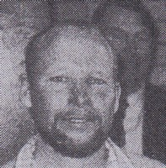
BSc ANU Forestry 1972. Worked for Forests Department/CALM at Nannup in mid 1980s and in Inventory & Planning in late 1980s. At Bunbury in 1990s. Transferred to Department of Resources Development in Bunbury 1997, as Planning Officer.

